

**Project Report on**

AI in HEALTHCARE (Diagnosis and Treatment Application)

(HEART-RISK CALCULATOR)

INTRODUCTION NAME - MOHAMMED FAIZAN

SECTION - K21QT

REGISTRATION NO - 12115149

GROUP - 1

SUBJECT - INT 404 (AI)

PROJECT REPORT TOPIC - HEART RISK CALCULATOR

SUBJECT TEACHER - AKSHARA MAM

COLLEGE - LOVELY PROFESSIONAL UNIVERSITY

|  |  |  |
| --- | --- | --- |
| Sr. No. | Topics | Page No. |
| 1 | Team Members & Roles and Responsibilities | 3 |
| 2 | Introduction-AI Software in Healthcare | 4 |
| 3 | Names of AI Software | 5 |
| 4 | Machine Learning Algorithms | 5 |
| 5 | Natural Language Processing | 6 |
| 6 | AI Software in HealthCare (Heart Risk Calculator) | 6 |
| 7 | Data Flow Diagram | 8 |
| 8 | Language Used | 10 |
| 9 | Progress of Work schedule in term of  GHANT CHART | 11 |
| 10 | Progress of Module Work Schedule in term of  GHANT CHART | 12 |

**TEAM MEMBERS FOR PROJECT ARE:**

|  |  |  |  |  |  |  |  |  |  |  |  |  |  |  |  |  |
| --- | --- | --- | --- | --- | --- | --- | --- | --- | --- | --- | --- | --- | --- | --- | --- | --- |
| |  |  |  | | --- | --- | --- | | **Name** | MOHAMMED FAIZAN | SUJOY DAS | | **Roll no** | 13 | 15 | | **Reg. no.** | 12115149 | 12116211 | | **Section** | K21QT | K21QT | | **Group** | 1 | 1 | |  |

**Roles And Responsibilities :**

1. Module 1: - Role 1: Mohammed Faizan

Responsibilities: 1 Making Pre-Submission and Hard-Copy-Report

2 Requirements & Design Analysis

3 Making Frontend Part (HTML, CSS)

2 Module 2: - Role 2: Sujoy Das

Responsibilities: 1 Making Seminar Report

2 Testing Work

3 Making Backed Part (JavaScript)

**INTRODUCTION**

**AI Software in Healthcare**

AI software is revolutionizing the healthcare industry by automating tedious tasks, providing more accurate diagnoses, and offering personalized treatment plans for patients. This technology is being used in a variety of ways, from detecting diseases earlier to reducing medical errors and improving patient outcomes.

One of the main advantages of AI software in healthcare is its ability to process large amounts of data quickly and accurately. Machine learning algorithms, natural language processing, and predictive analytics are just a few examples of AI technologies used in healthcare. By analysing patient data, AI software can detect patterns and predict outcomes, which can help healthcare providers make more informed decisions about patient care.

AI software is also being used to diagnose diseases more accurately. For example, a study published in the journal Nature Medicine found that an AI system was able to diagnose skin cancer with the same accuracy as a team of dermatologists. Similarly, AI software is being used to diagnose other diseases, such as breast cancer and heart disease, with high levels of accuracy.

In addition to diagnosis, AI software is being used to develop new drugs. By analysing vast amounts of data, AI systems can identify potential drug candidates and predict their efficacy. This can help pharmaceutical companies save time and money in the drug development process.

AI software is also being used to automate administrative tasks, such as data entry and record-keeping. By automating these tasks, healthcare providers can save time and reduce the risk of errors.

In conclusion, AI software is transforming the healthcare industry by providing more accurate diagnoses, developing new drugs, automating administrative tasks, and facilitating telehealth consultations. As AI technology continues to evolve, we can expect to see even more applications of this technology in healthcare in the years to come.

## Names of AI Software

There are many types of AI software used in healthcare, such as IBM Watson, Google DeepMind, and Microsoft Azure. These technologies can be used to detect diseases earlier, reduce medical errors, and improve patient outcomes.

Other AI software used in healthcare includes Nuance Dragon Medical, NVIDIA Clara, and GE Healthcare Edison etc. These technologies can be used to automate tedious tasks, such as data entry, and to make more accurate diagnoses.

* + IBM Watson
  + Google DeepMind
  + Microsoft Azure
  + Nuance Dragon Medical
  + NVIDIA Clara
  + GE Healthcare Edison
  + Cogito
  + UiPath
  + Atomwise
  + Zebra Medical Vision
  + Ada Health
  + Babylon Health

Overall, AI software applications in healthcare have the potential to transform the industry by improving patient outcomes, reducing costs, and increasing efficiency. As AI technology continues to evolve, we can expect to see even more innovative applications emerging in the healthcare industry.

## Machine Learning Algorithms

Machine learning algorithms are used to analyse large amounts of data and identify patterns. They can be used to detect diseases earlier, reduce medical errors, and improve patient outcomes. Machine learning algorithms can also be used to automate tedious tasks, such as data entry.

Machine learning algorithms can also be used to provide personalized treatment plans for patients. They can also be used to streamline administrative tasks, such as billing and scheduling. Machine learning algorithms can also be used to provide personalized patient care, such as providing reminders for appointments and medication refills.

## Natural Language Processing

Natural language processing (NLP) is a type of AI software used to analyse and interpret human language. It can be used to detect diseases earlier, reduce medical errors, and improve patient outcomes. NLP can also be used to automate tedious tasks, such as data entry.

NLP can also be used to provide personalized treatment plans for patients. It can also be used to streamline administrative tasks, such as billing and scheduling. NLP can also be used to provide personalized patient care, such as providing reminders for appointments and medication refills.

**AI Software in Healthcare (Heart Risk Calculator)**

Artificial intelligence (AI) is revolutionizing the healthcare industry. From drug discovery to patient care, AI is being used to improve efficiency, accuracy, and outcomes. One area where AI is making a significant impact is in the development of heart risk calculators. These tools use algorithms to analyse a range of patient data and determine an individual's risk of developing heart disease. While heart risk calculators offer numerous benefits, they also have some limitations that need to be considered.

Heart disease is a leading cause of death globally, with millions of people dying every year. The key to preventing heart disease is identifying and managing the risk factors early. To achieve this, healthcare providers have traditionally used heart risk calculators to determine an individual's risk of developing heart disease. However, traditional risk calculators have limitations in their ability to account for all possible risk factors. This is where artificial intelligence (AI) comes in.

AI-powered heart risk calculators are designed to provide a more accurate assessment of an individual's risk of developing heart disease by analysing a range of patient data using complex algorithms. These calculators can consider a wide range of variables, including age, gender, blood pressure, cholesterol levels, family history, lifestyle factors, and genetics, among others. By analysing this information, AI-powered heart risk calculators can provide a more comprehensive and personalized risk assessment than traditional calculators.

**Advantages of Heart Risk Calculator using AI**

**Increased accuracy:** Heart risk calculators that use AI algorithms can take into account a range of variables that traditional risk calculators cannot. These variables include factors such as family history, lifestyle, and genetics. By analysing this information, AI-powered heart risk calculators can provide more accurate risk assessments.

**Personalized treatment:** Because AI-powered heart risk calculators can provide more detailed risk assessments, doctors can create personalized treatment plans that take into account a patient's unique risk factors. This can help improve patient outcomes and reduce the likelihood of future heart problems.

**Efficiency:** AI-powered heart risk calculators can analyse patient data more quickly and accurately than traditional risk calculators. This can help doctors make faster and more informed decisions, leading to better patient care.

**Cost-effective:** By reducing the need for expensive and time-consuming tests, AI-powered heart risk calculators can save money and resources for both patients and healthcare providers.

**Disadvantages of Heart Risk Calculator using AI**

**Limited data**: AI-powered heart risk calculators rely on patient data to provide risk assessments. However, if a patient's data is incomplete or inaccurate, the risk assessment may not be reliable.

**Bias:** AI algorithms can be biased if they are not properly designed and trained. This can result in inaccurate risk assessments, especially for patients from certain demographic groups.

**Limited human input:** AI-powered heart risk calculators rely solely on algorithms to provide risk assessments. While this can be efficient, it also means that there is limited opportunity for human input or oversight.

**Conclusion**

Heart risk calculators using AI algorithms have numerous benefits, including increased accuracy, personalized treatment, efficiency, and cost-effectiveness. However, there are also some limitations that need to be considered, such as limited data, bias, and limited human input. Healthcare providers must weigh these pros and cons when deciding whether to use AI-powered heart risk calculators in their practice. While AI technology has the potential to revolutionize healthcare, it must be used responsibly and ethically to ensure the best possible outcomes for patients.

In conclusion, AI-powered heart risk calculators have the potential to revolutionize the prevention and management of heart disease. By providing more accurate and personalized risk assessments, these calculators can help healthcare providers identify and manage risk factors early, ultimately leading to improved health outcomes for patients. Nevertheless, it is important to ensure that the algorithms are properly designed and tested to avoid bias and that the data used to train the algorithms is of high quality.

**Data Flow Diagram:**

A data flow diagram (DFD) is a graphical representation of the "flow" of data through an information system, modelling its process aspects. Often, they are a preliminary step used to create an overview of the system which can later be elaborated. DFDs can also be used for the visualization of data processing (structured design). A DFD shows what kinds of data will be input to and output from the system, where the data will come from and go to, and where the data will be stored. It does not show information about the timing of processes, or information about whether processes will operate in sequence or in parallel (which is shown on a flowchart).

Level 0:

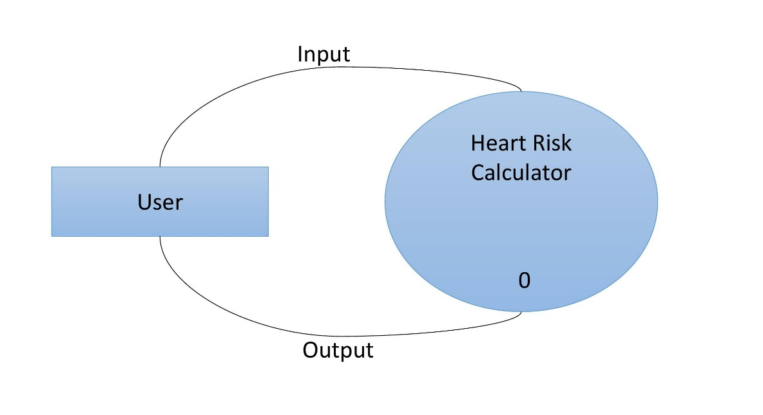

Level 1:

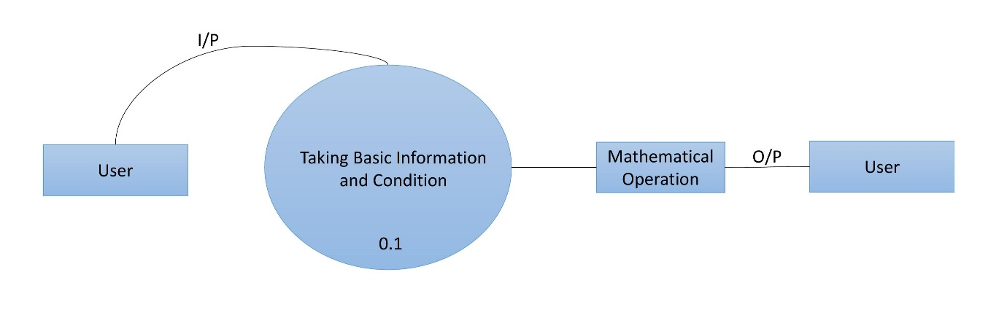

**LANGUAGE USED**

HTML:

HTML, or Hypertext Markup Language, is the standard language used to create web pages. It defines the structure and content of a web page using tags and attributes. HTML documents consist of elements, which can be text, images, videos, links, and more. HTML is a fundamental part of web development and is used to create the basic structure of a website. HTML5 is the latest version of the language, which includes new features like multimedia support, semantic elements, and form controls.

CSS:

CSS, or Cascading Style Sheets, is a stylesheet language used to describe the presentation of HTML or XML documents. It allows web developers to control the layout, typography, colours, and other visual aspects of a web page. CSS rules consist of selectors and declarations, where selectors identify which HTML elements the styles should be applied to, and declarations define the styles themselves. CSS can be applied to a web page either through an external file or in-line with HTML.

JAVASCRIPT:

JavaScript is a high-level programming language that is widely used to create interactive web pages and web applications. It allows developers to add dynamic behaviour and interactivity to their web pages. JavaScript code can be embedded directly into HTML documents or loaded from external files. It is used to create features like drop-down menus, pop-up windows, and animations. JavaScript can also be used to manipulate the Document Object Model (DOM) of a web page, which allows developers to dynamically change the content and structure of a web page without reloading it

**Progress of work schedule in terms of Gantt chart:**

|  |  |  |  |  |  |
| --- | --- | --- | --- | --- | --- |
| **Task Name** | **Start Date** | **End Date** | **Duration (Days)** | **Days Complete** | **Percent Complete** |
| Requirement analysis | 20/03/2023 | 23/03/2023 | 4 | 4 | 100% |
| Design | 23/03/2023 | 26/03/2023 | 4 | 4 | 100% |
| Coding | 26/03/2023 | 01/04/2023 | 7 | 7 | 100% |
| Testing | 01/04/2023 | 07/04/2023 | 7 | 7 | 100% |

**Progress of Module work schedule in terms of Gantt chart:**

|  |  |  |  |  |  |
| --- | --- | --- | --- | --- | --- |
| **Name** | **Module** | **Start Date** | **End Date** | **Duration (Days)** | **Percent Complete** |
| MOHAMMED FAIZAN | Module 1 | 20/03/2023 | 07/04/2023 | 19 | 100% |
| SUJOY DAS | Module 2 | 20/03/2023 | 07/04/2023 | 19 | 100% |